Flashing Control
Objective: use the motor as a rotary control to change the rate of flashing and the color.

The Build
Build from pictures (and parts list).
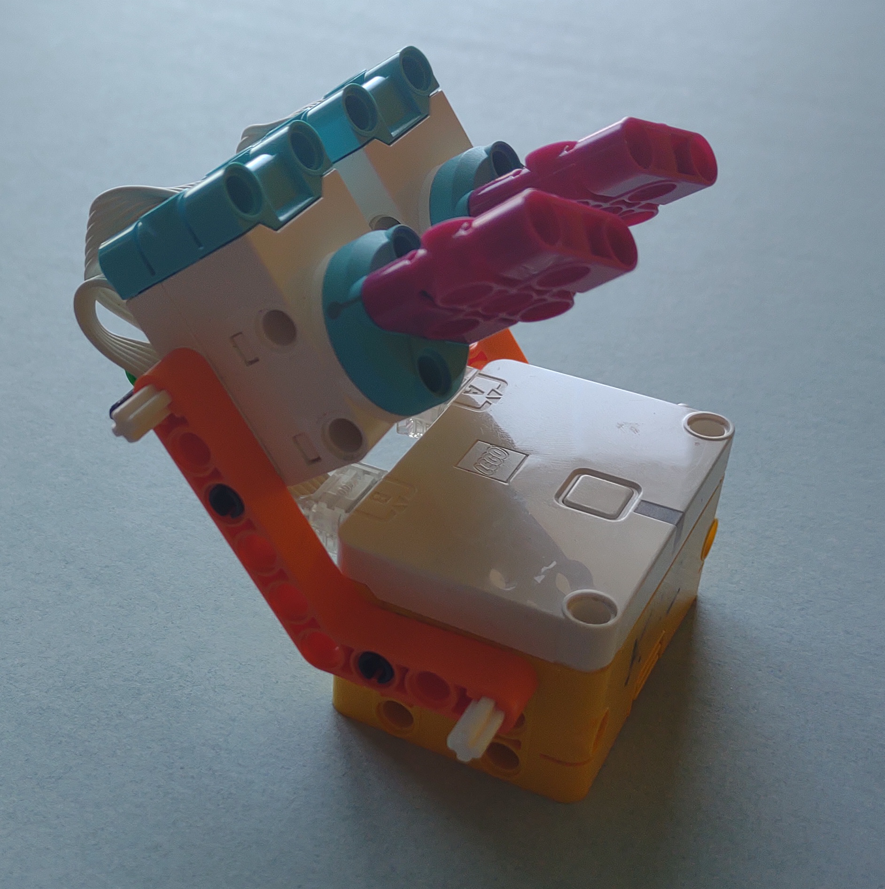
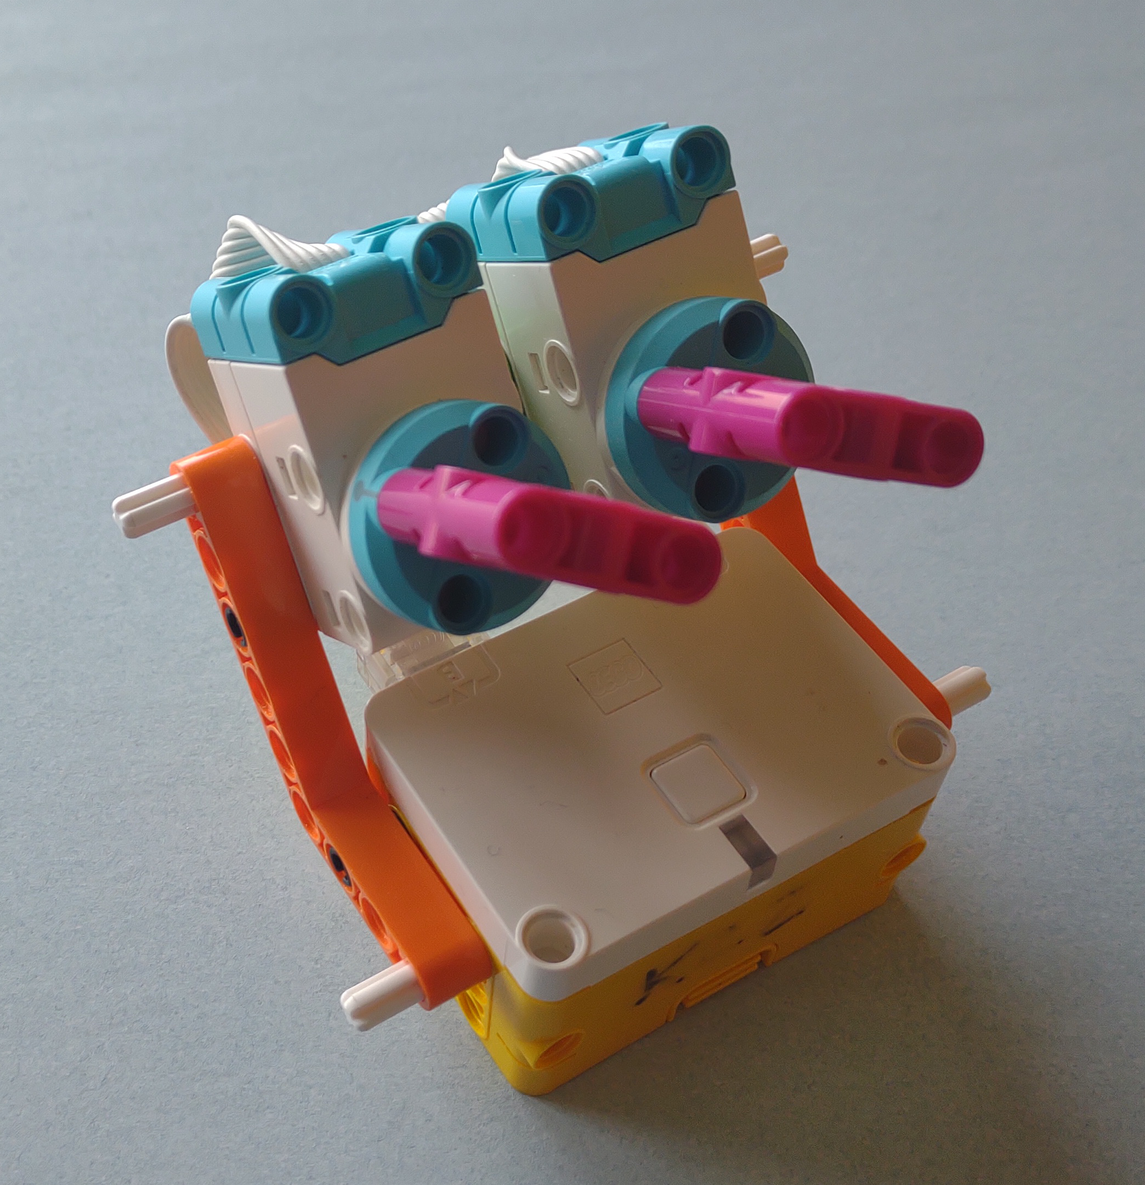
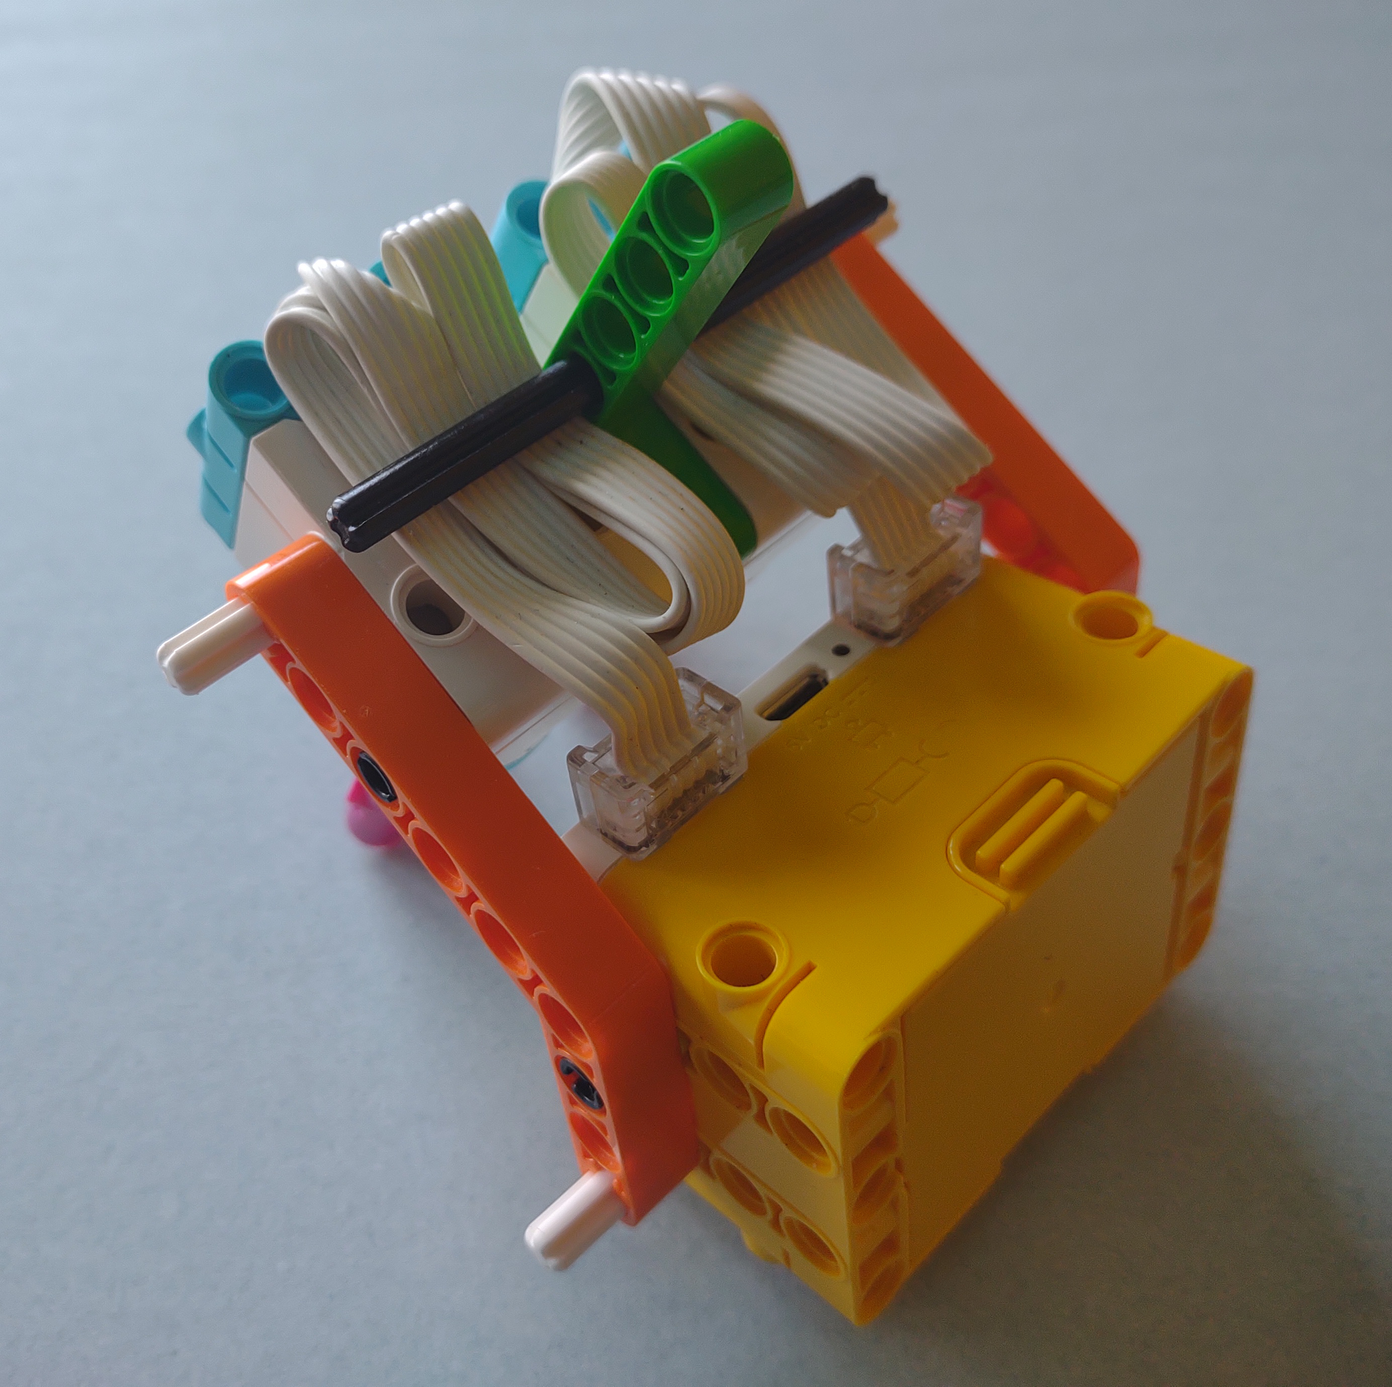

Parts:
1- Hub (yellow-white)
2- small motors (blue-white)
2- liftarm bent 4x6 45° (orange)
1- liftarm bent 3x5 90° (green)
6- axle pin with 2L axle (white)
8- pin (black)
2- beam 3x3 (mauve)
1- axle 8 (black)

What do the controls remind you of? (hint: think of appliances in your home.)

The Code
Create a variable called “delay”
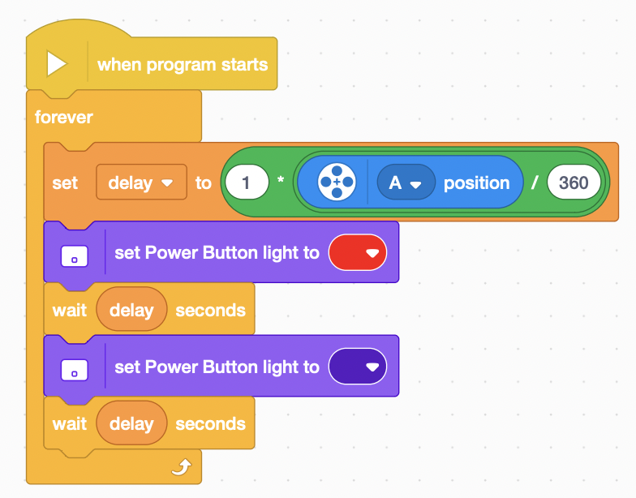

The Code Part II
Use the second motor to control the color of the light. (color is a number between 1 and 10).
Create another variable for color.
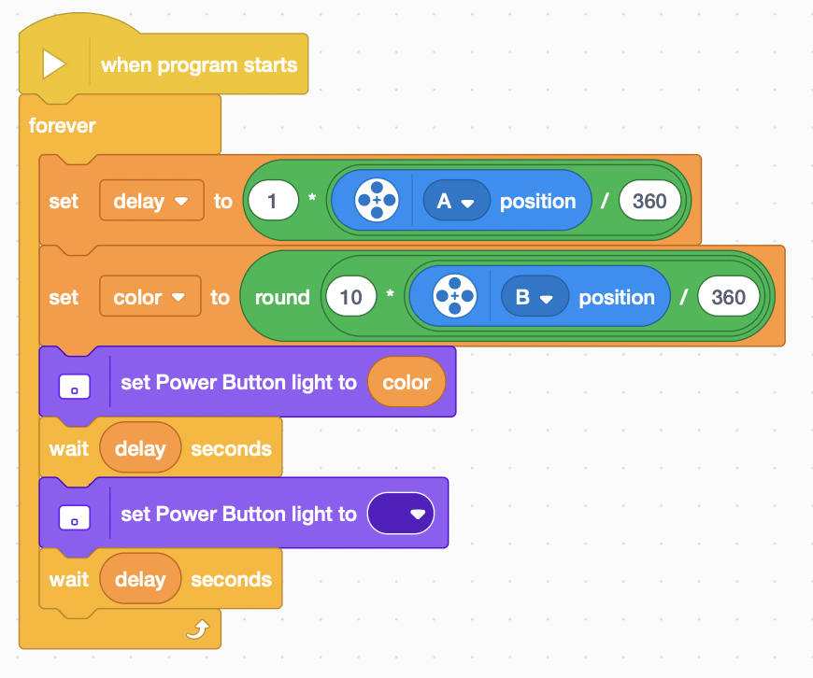

The Code Part III
Use one control to select a sound (use a set of if-else or if-than-else blocks to select sound based on a number).
Use another control to control the pitch or volume of the selected sound.
Use sounds that are short to better experience the effects.
What changes are necessary to the other code.

